Singletone

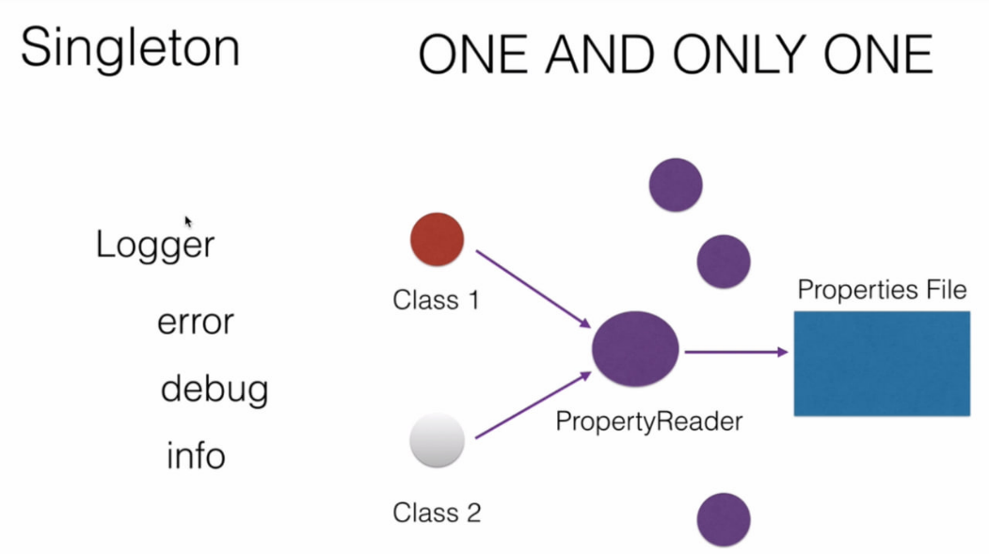

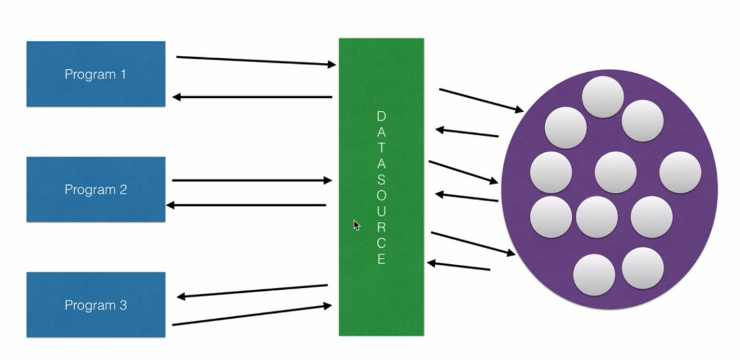

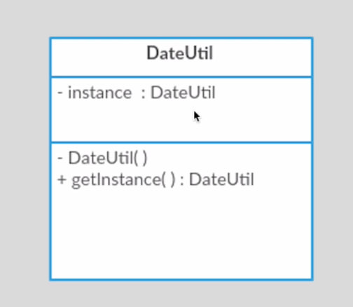

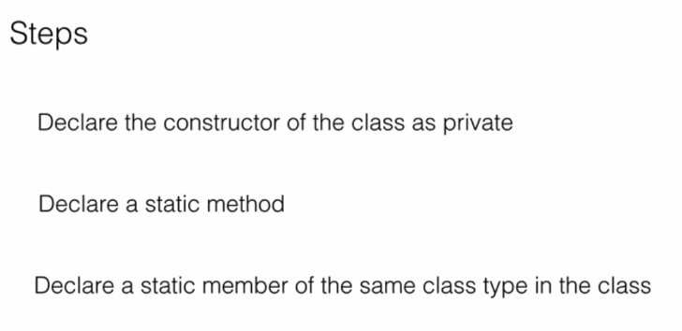

- Create Singleton class
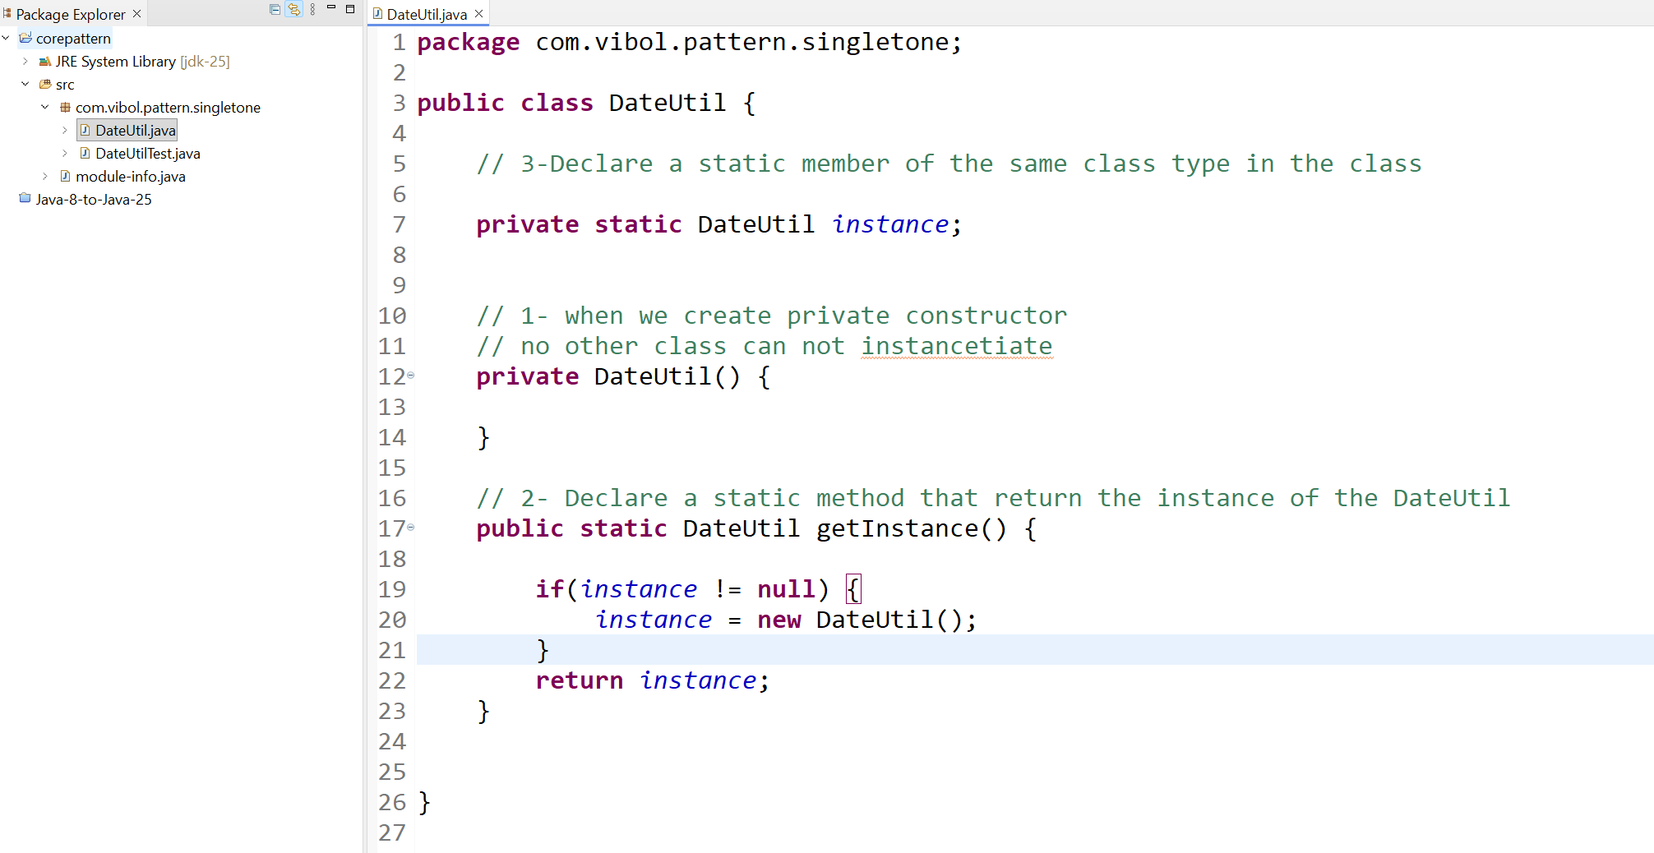

- Test Instance the same create
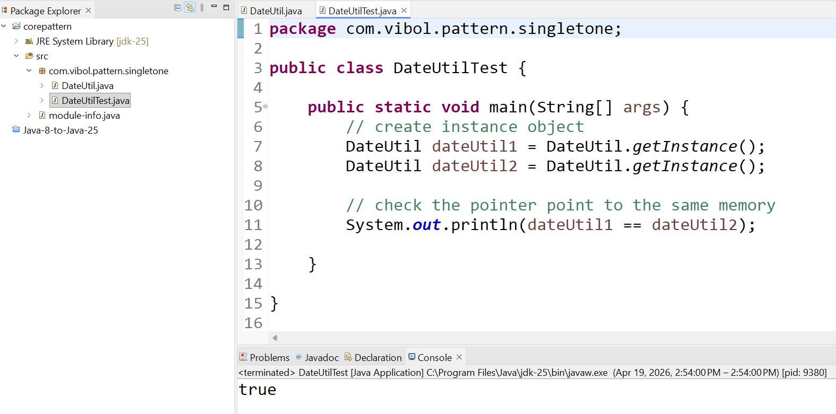

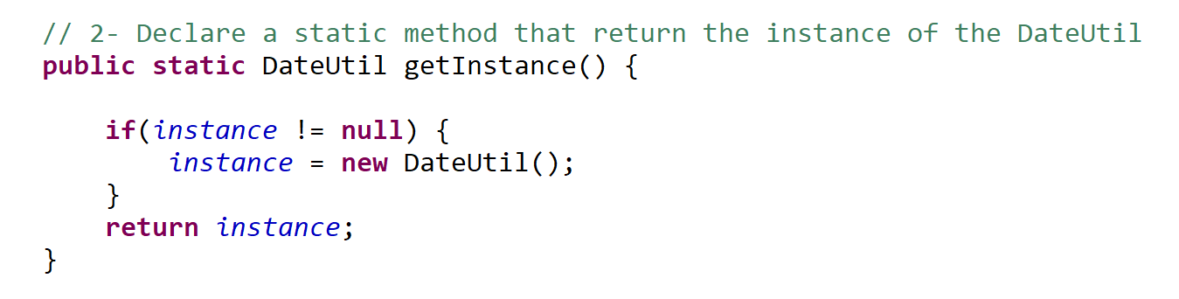
- Eager Initialization បង្កើតមុន

This above called lazily creation : ពេលហៅបានវាបង្កើតអោយយើង
យើងបង្កើត Instance ពេលដែល getIntance invoke
- យើងអាចបង្កើតតាមលក្ខណៈ Eager Initialization ពេលដែលហៅគឺអោយ Object នឹងបង្កើតតែម្តង
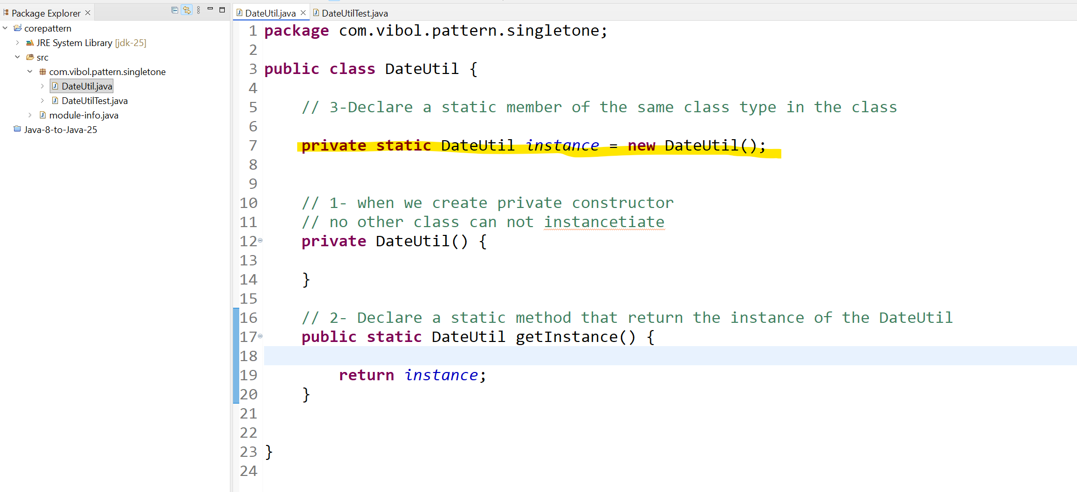

- របៀបមួយទៀត យើងអាបង្កើត Eager Initialization តាមរយៈ static block
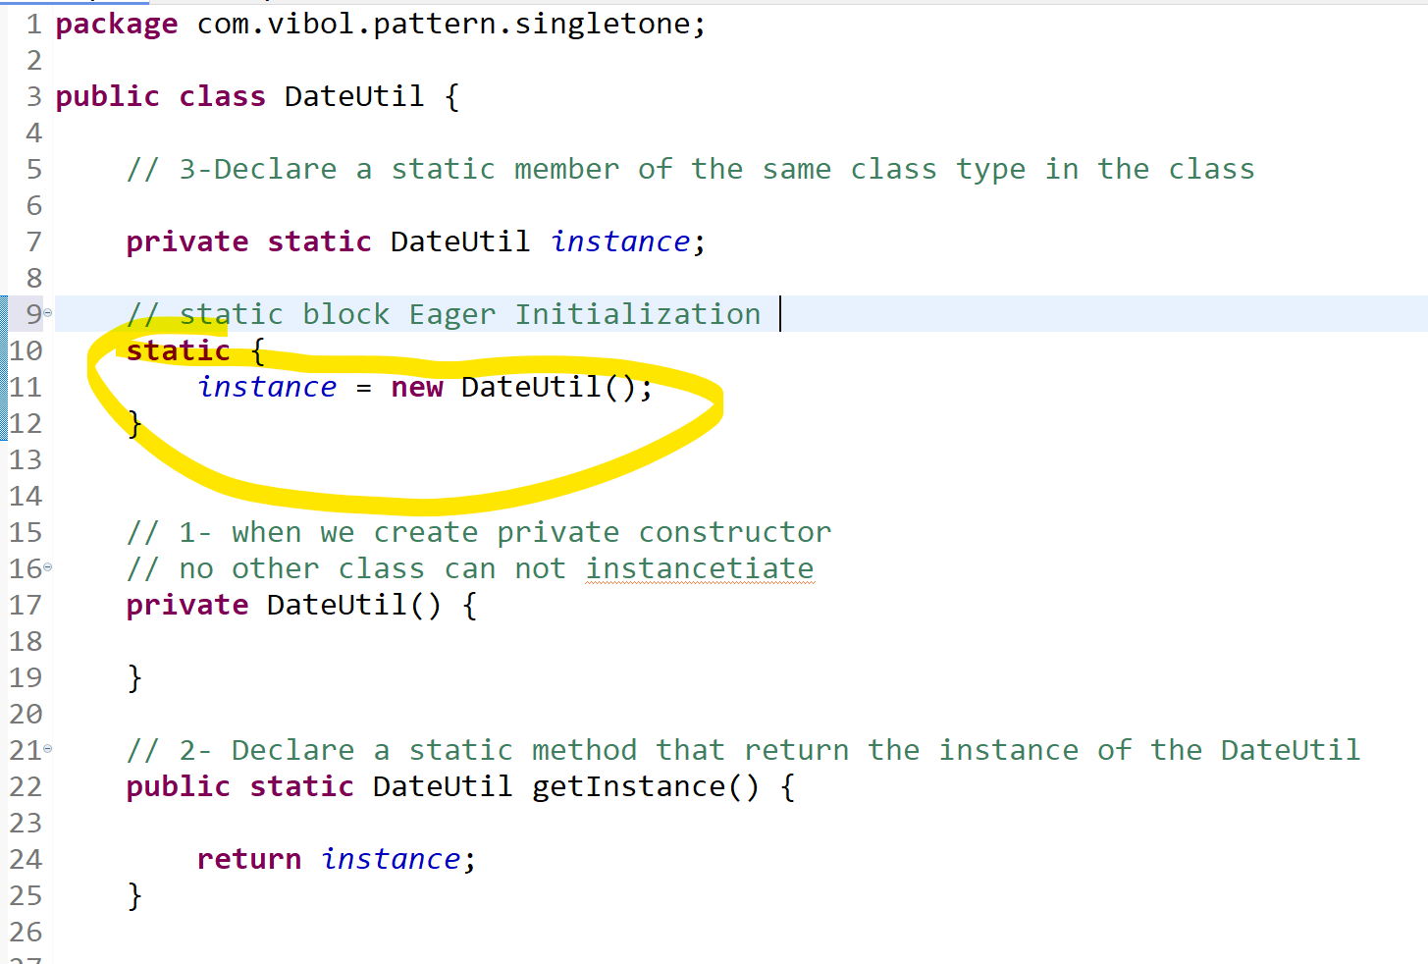

Note : static block in java are excuted when the class is loaded into Memory

- If you are pretty sure that your singleton instance will be used at least once in the
Application​ because the instance will be created right when the class is loaded or when the class is being used

យើងប្រើវានៅពេលដែលដឹងថា application ត្រូវការបង្កើត Instance ពេលបើកមកដំបូង តែជាទូទៅគេប្រើប្រាស់ ជាលក្ខណៈ Lazy ពេលហៅបានអោយវាបង្កើត

- Thread Safe
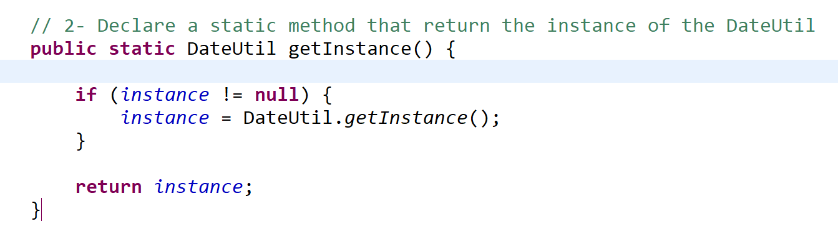

ពេលដែលយើងបង្កើត Instance តាមរបៀបនឹងវាអាចមានករណី Multi Thread that can make two instance in the same time to perveance this happening we use key work “synchronized” that will make the instance have only one object.

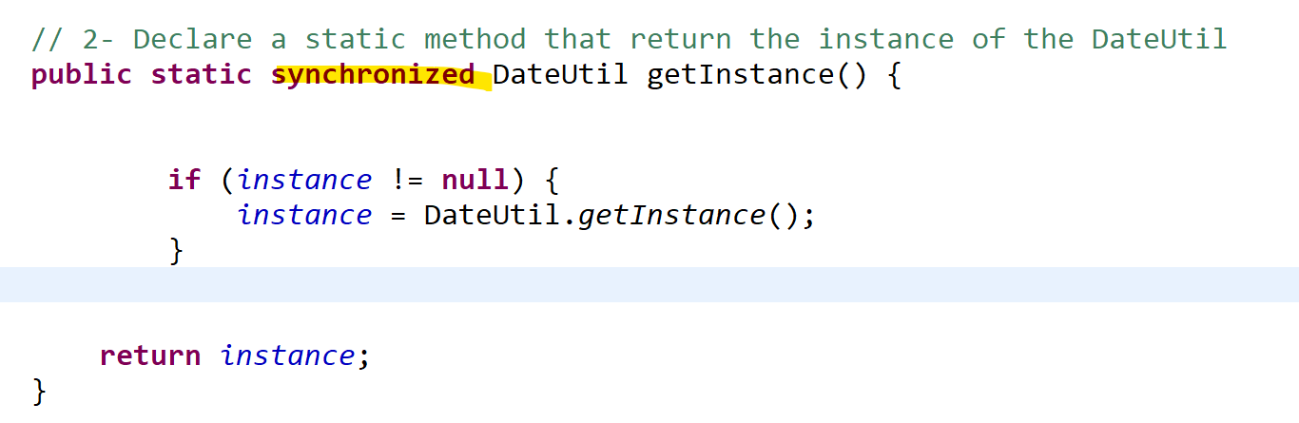

Or we can create block for thread :
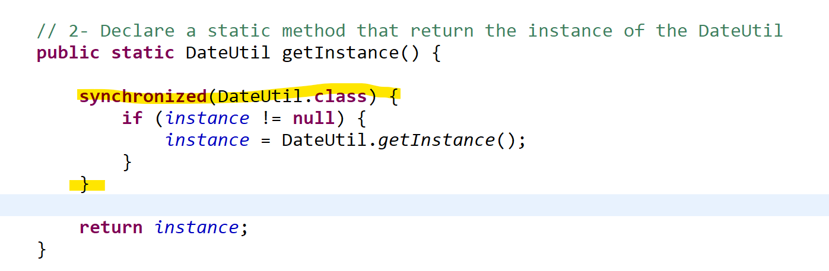

This synchronized block will confirm no other thread can access this block.
Improve Multi Threading :

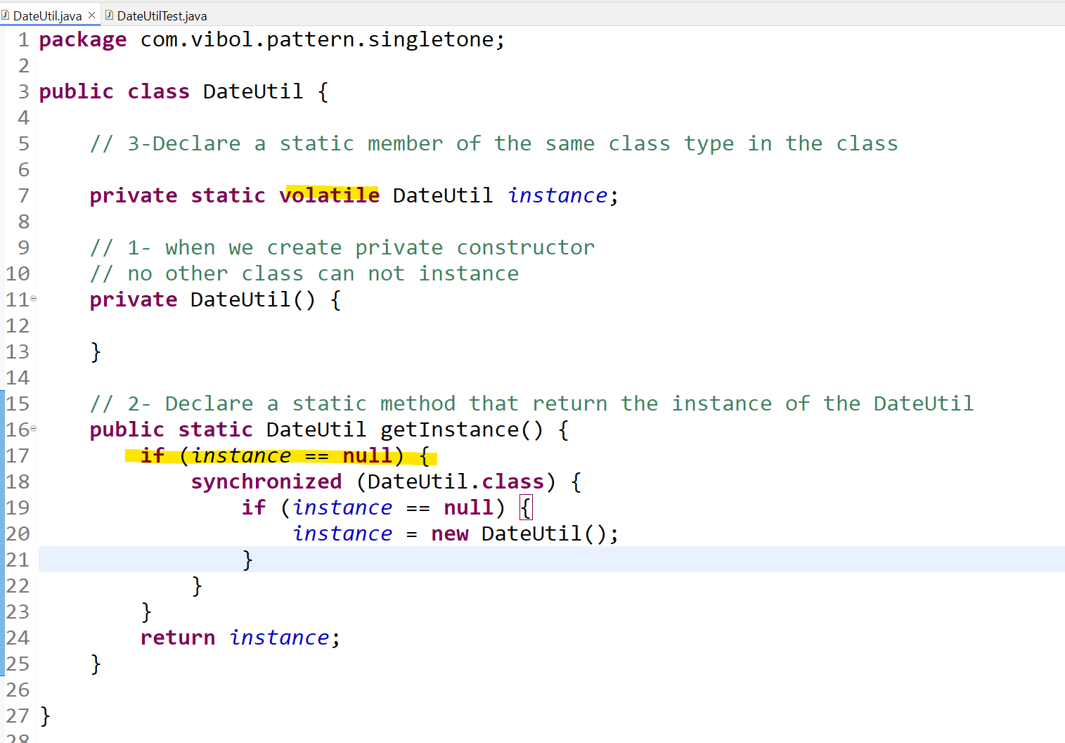

- Check the instance == null បើវាអត់មាន Object បានអោយវាបង្កើត បើវាមានហើយ គឺមិនអោយបង្កើតទេ
- Put word “volatile” បង្កើតអោយ Thread តែមួយវាអ្នកធ្វើការ

- Handle with serialization and deserialization

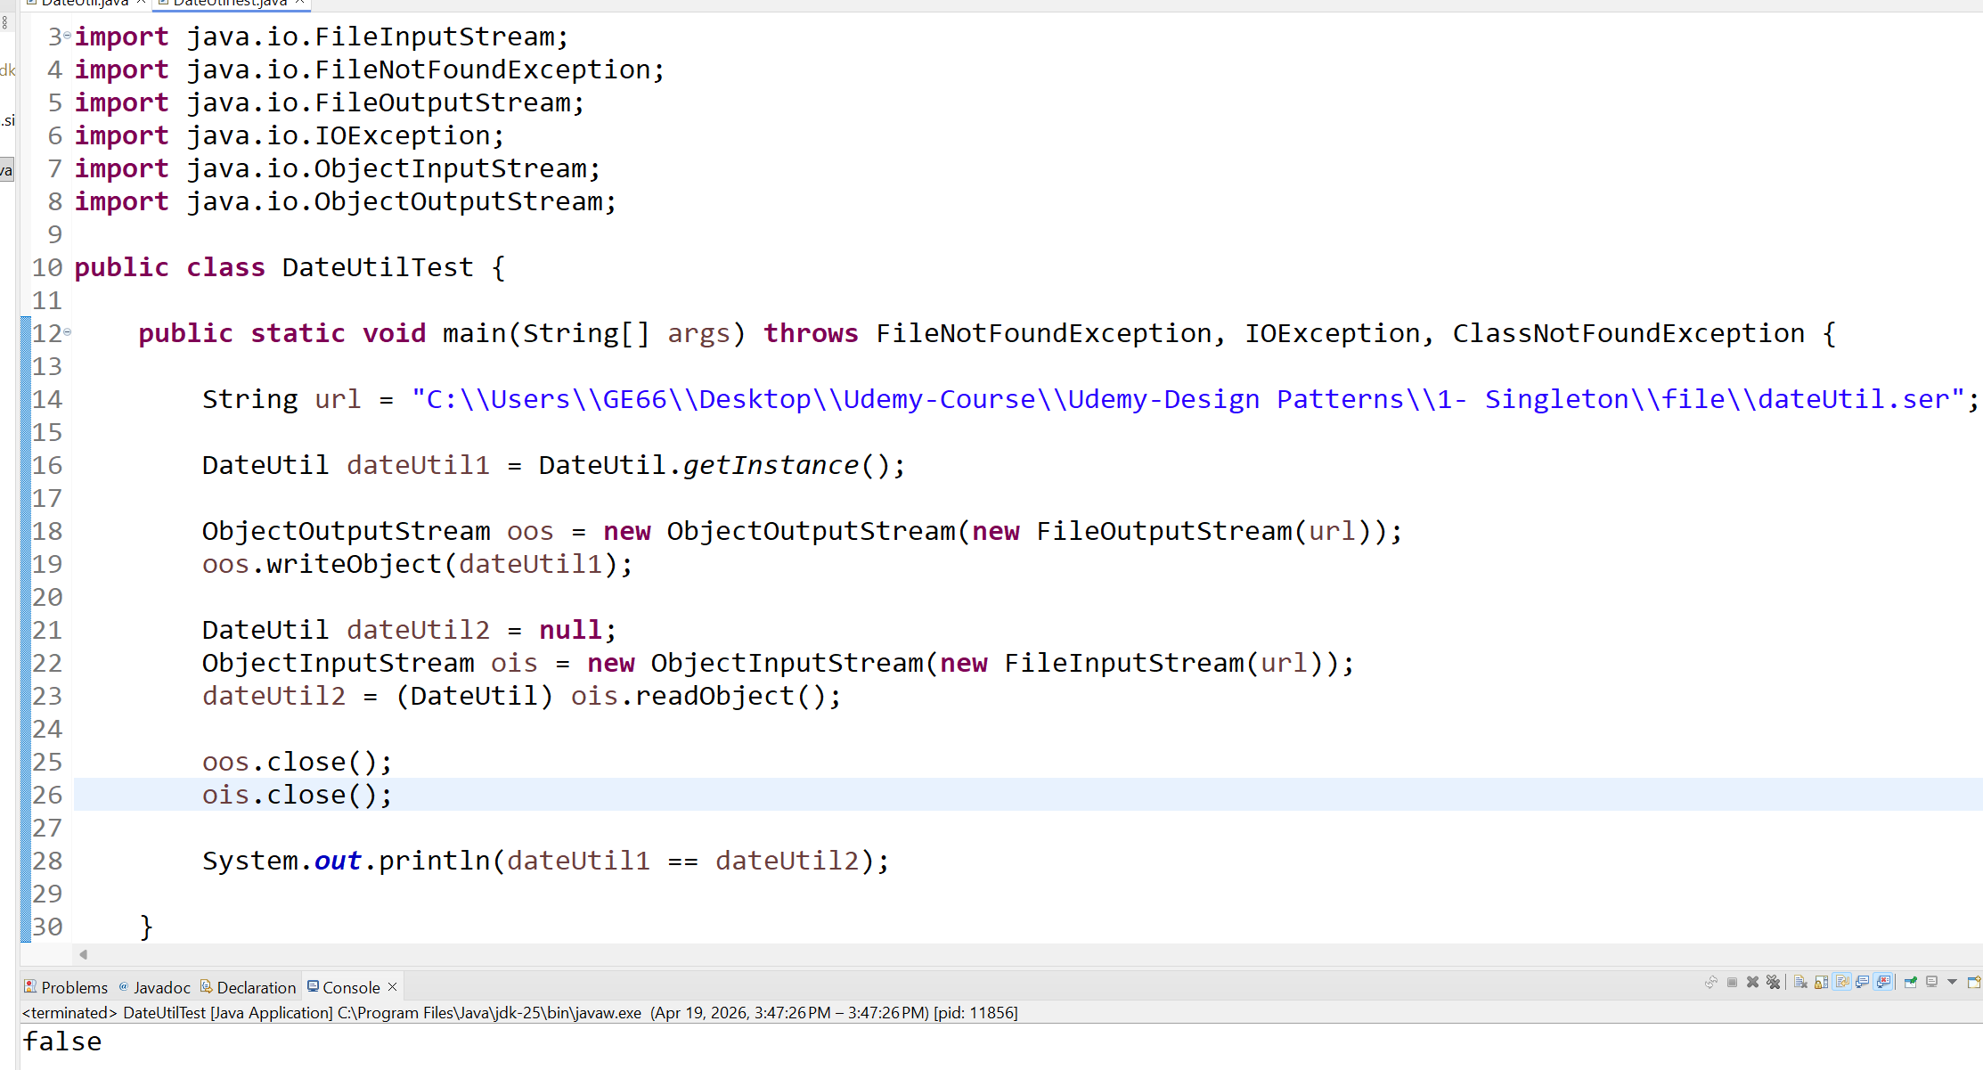

ពេលដែលយើងធ្វើការសរសេរ read and write file it created difference instance

5-1 Solution on serialization
ដោយសារតែ យើងចង់អោយ វា return object ដដែលចឹងយើងបង្កើត Object នៅក្នុង class អោយហើយ
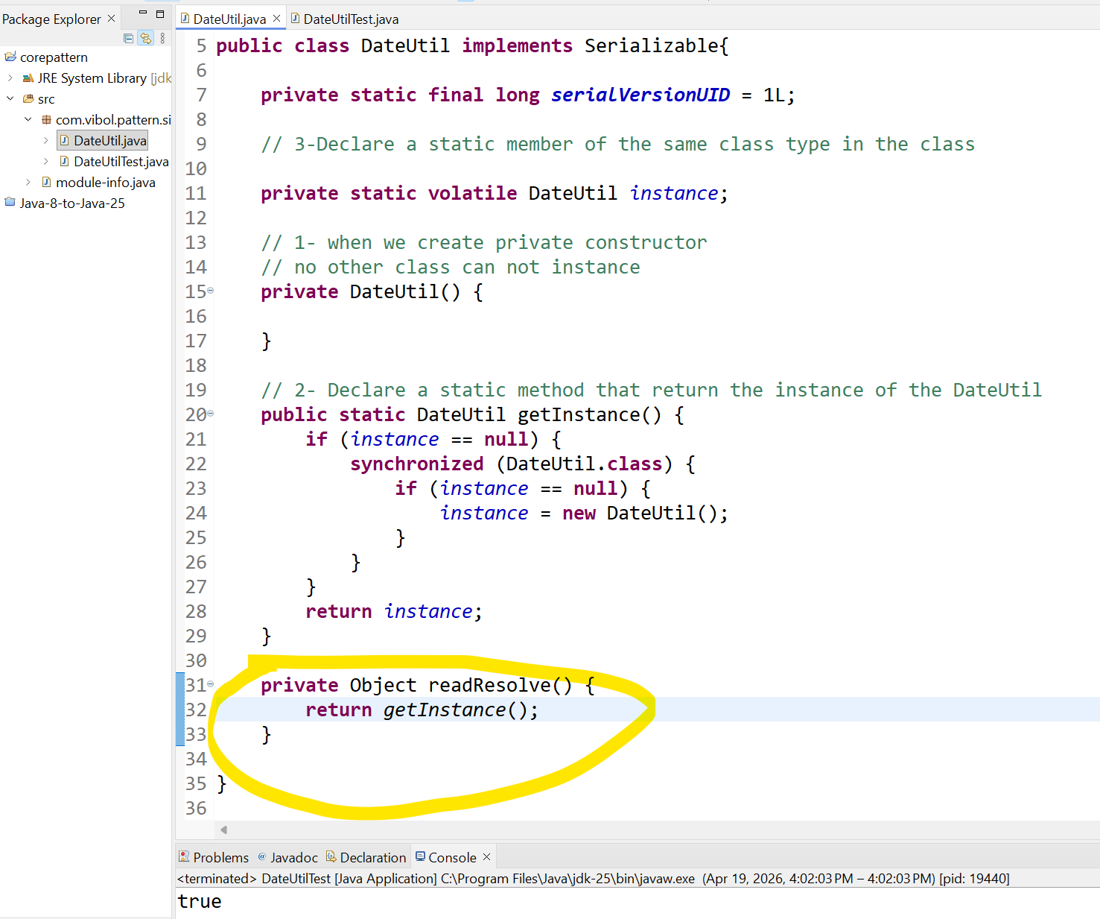

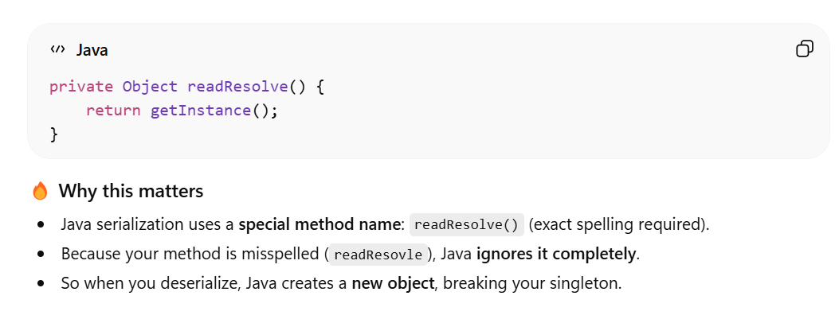

ដើម្បីកុំអោយ class ដទៃធ្វើការ Access មកបានយើងអាចដាក់ថា

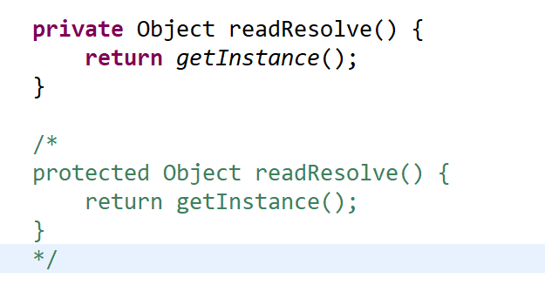

- Prevence clone object
Some client class want to clone our singletone but we don’t want to we can set them not clone.

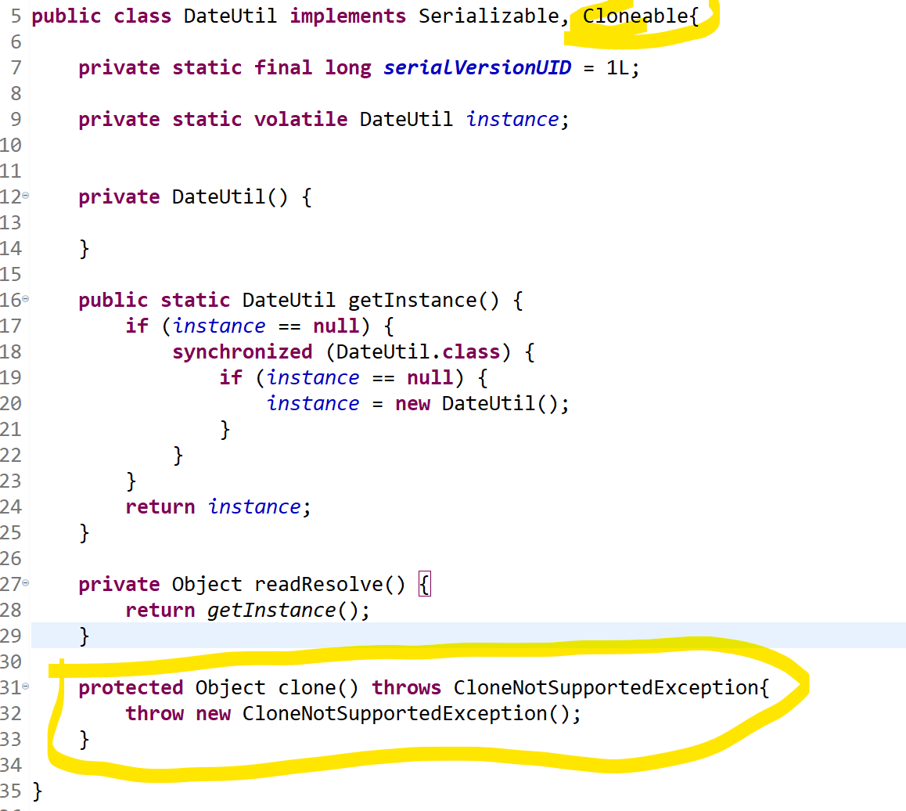

- Reflection Problem

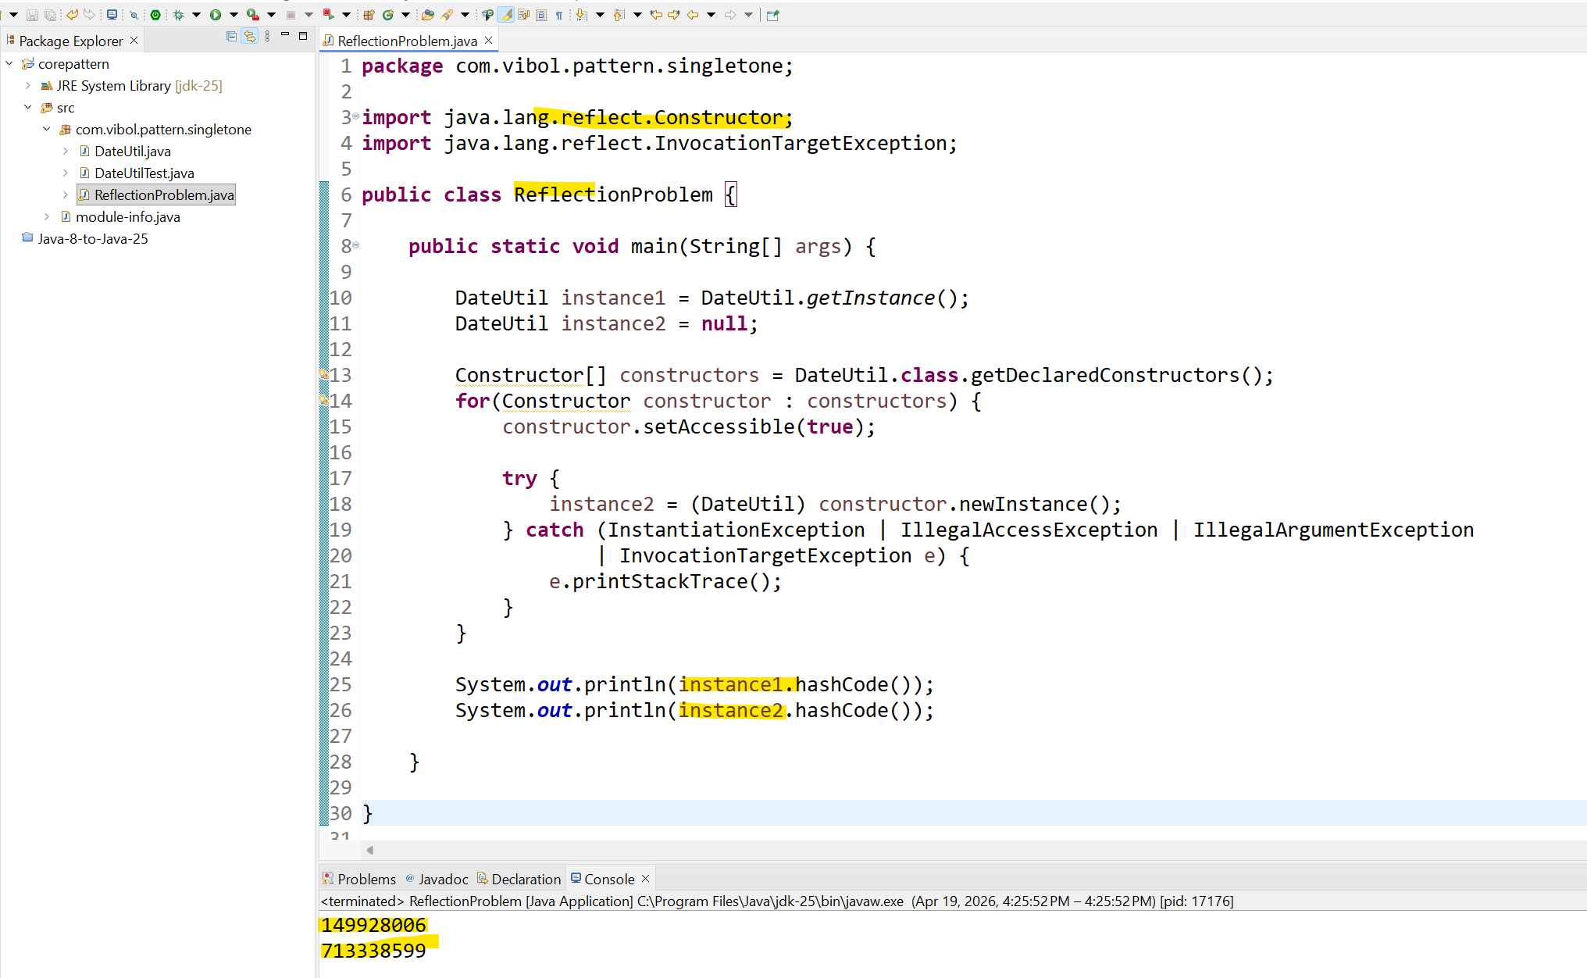

package com.vibol.pattern.singletone;

import java.lang.reflect.Constructor;
import java.lang.reflect.InvocationTargetException;

public class ReflectionProblem {

public static void main(String[] args) {

DateUtil instance1 = DateUtil.getInstance();
DateUtil instance2 = null;

Constructor[] constructors = DateUtil.class.getDeclaredConstructors();
for(Constructor constructor : constructors) {
constructor.setAccessible(true);

try {
instance2 = (DateUtil) constructor.newInstance();
} catch (InstantiationException | IllegalAccessException | IllegalArgumentException
| InvocationTargetException e) {
e.printStackTrace();
}
}

System.out.println(instance1.hashCode());
System.out.println(instance2.hashCode());

}

}

ដោយប្រើប្រាស់ Reflection យើងអាចធ្វើការបង្កើត Instance ថ្មីបានសម្រាប់ Singletone

- Solve the problem with from Reflection
យើងប្រើប្រាស់ Enum ដោយសារតែ Enum in the Java it doesn’t have constructor so we can not create break it by Reflection

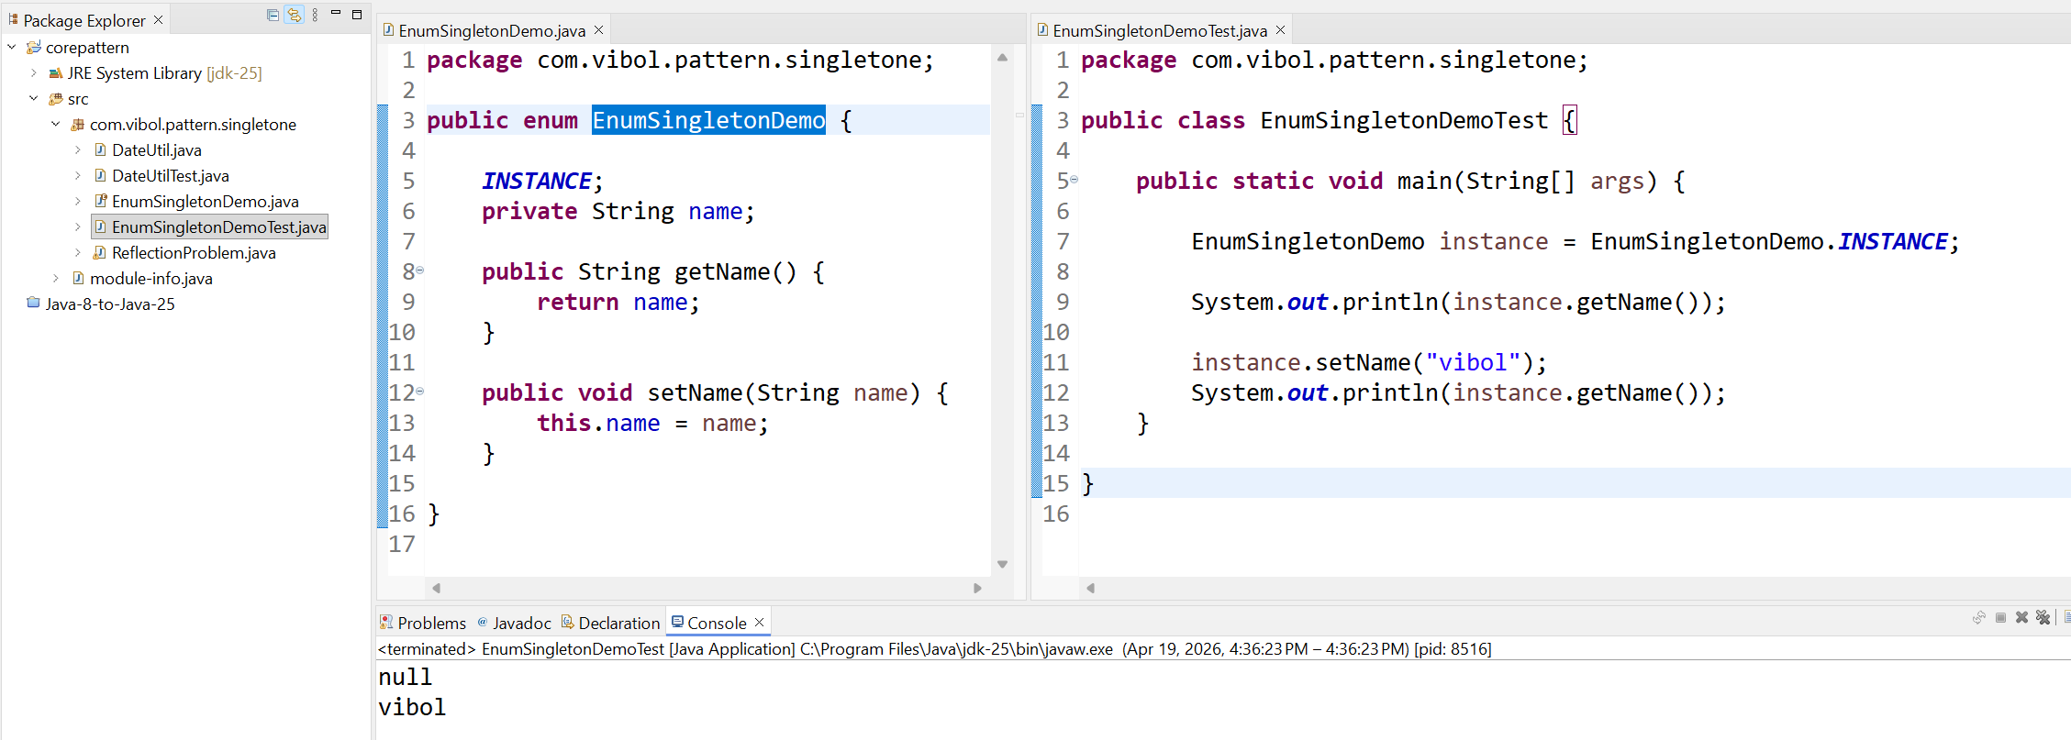

យើងឃើញថា វាមិនអាច Set new name បានទេ ដូចនេះ យើងអាចបង្កើត singletone from Enum បានដូចគ្នា

Code :
- DateUtile

package com.vibol.pattern.singletone;

import java.io.Serializable;

public class DateUtil implements Serializable, Cloneable{

private static final long serialVersionUID = 1L;

private static volatile DateUtil instance;

private DateUtil() {

}

public static DateUtil getInstance() {
if (instance == null) {
synchronized (DateUtil.class) {
if (instance == null) {
instance = new DateUtil();
}
}
}
return instance;
}

private Object readResolve() {
return getInstance();
}

protected Object clone() throws CloneNotSupportedException{
throw new CloneNotSupportedException();
}

}

- DateUtilTest

package com.vibol.pattern.singletone;

import java.io.FileInputStream;
import java.io.FileNotFoundException;
import java.io.FileOutputStream;
import java.io.IOException;
import java.io.ObjectInputStream;
import java.io.ObjectOutputStream;

public class DateUtilTest {

public static void main(String[] args) throws FileNotFoundException, IOException, ClassNotFoundException {

String url = "C:\\Users\\GE66\\Desktop\\Udemy-Course\\Udemy-Design Patterns\\1- Singleton\\file\\dateUtil.ser";

DateUtil dateUtil1 = DateUtil.getInstance();

ObjectOutputStream oos = new ObjectOutputStream(new FileOutputStream(url));
oos.writeObject(dateUtil1);

DateUtil dateUtil2 = null;
ObjectInputStream ois = new ObjectInputStream(new FileInputStream(url));
dateUtil2 = (DateUtil) ois.readObject();

oos.close();
ois.close();

System.out.println(dateUtil1 == dateUtil2);

}

}

- Enum
package com.vibol.pattern.singletone;

public enum EnumSingletonDemo {

INSTANCE;
private String name;

public String getName() {
return name;
}

public void setName(String name) {
this.name = name;
}

}

- Test Enum

package com.vibol.pattern.singletone;

public class EnumSingletonDemoTest {

public static void main(String[] args) {

EnumSingletonDemo instance = EnumSingletonDemo.INSTANCE;

System.out.println(instance.getName());

instance.setName("vibol");
System.out.println(instance.getName());
}

}

